**Mohammad Daniyal Danish, 6-P**

Making mental health a global priority

Have you ever thought about your mental health? Well, it is a crucial thing to consider. Being mentally healthy affects physical health positively, eases the management of emotions, and reduces the chances of mental illness. Let's explore these further.

Mental and physical health are two things that cause problems later in life if not maintained properly – our minds & bodies *aren’t* seperate. People who suffer from depression get headaches and suffer from fatigue. Anxiety comes with an upset stomach. However, happy people tend to be more active and energetic. Being mentally healthy has a positive effect on physical health.

Managing emotions is one of the problems children, teenagers, or adults might face. Teenagers might misbehave with their parents, young kids could cry, and adults can rage – the effects of the mismanagement of emotions. But, being mentally healthy prevents these problems from harming us. Good feelings & and thoughts arise from being mentally healthy. The most important decision you make is to be in a good mood.

Mental illness is a condition that causes severe disorders in a person's behavior or *thinking*, such as peer pressure, bulimia, anorexia, stress, anxiety, etc. According to the CDC, 1 in 5 children in the USA experience such mental illnesses. In some countries, mental illnesses have led young children and teenagers to commit terrible crimes. But being mentally healthy repels all mental illnesses away, because of positive thinking. Mental health is just as good as physical health.

Mental health should be maintained the way people nowadays take care of their physical health (properly). Affecting physical health positively, easing the management of emotions, & reducing the chances of mental illness – because of all of this we can agree with John Green's statement:

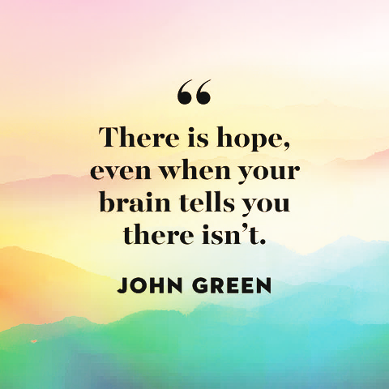

References and credits:

* <https://www.goodhousekeeping.com/life/a39739060/mental-health-quotes/> for quote and image, Page 2
* Word add-in *Icons by Noun Project* for icon, top right, Page 1
* Google info for paragraphs 2, 3
* <https://www.cdc.gov/childrensmentalhealth/data.html#:~:text=Facts%20about%20mental%20disorders%20in,diagnosed%20mental%20disorders%20in%20children>. for paragraph 4